Grafika

Graphics (from Greek γραφικός graphikos) are visual presentations on some surface, such as a wall, canvas, computer screen, paper, or stone to brand, inform, illustrate, or entertain.
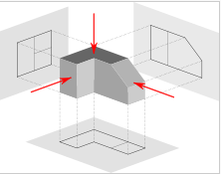
Photographs
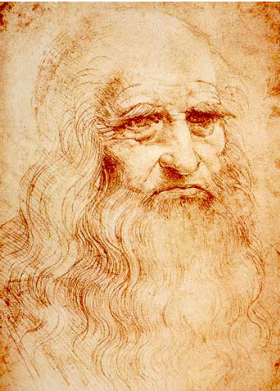
Drawings
Line Art
Graphs
Diagrams
Typography
Symbols
Geometric designs
Maps
Engineering drawings
Other images
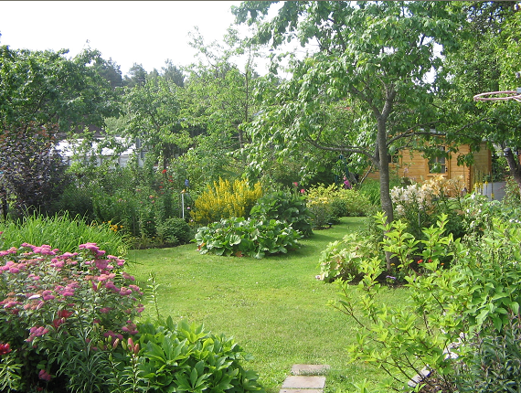

Datora grafika (computer graphics)

Computer graphics are graphics created using computers and, more generally, the representation and manipulation of image data by a computer.

Attēli
Grafiki
Shēmas (rasējumi)
Animācijas

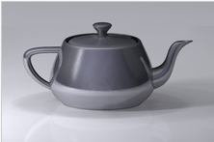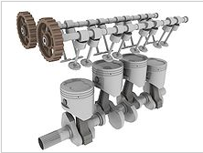

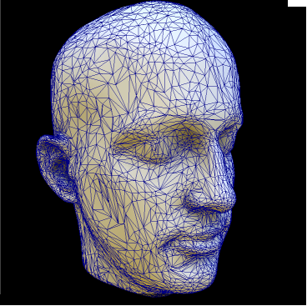

Skaitļošanas ģeometrija (computational geometry)

Computational geometry is a branch of computer science devoted to the study of algorithms which can be stated in terms of geometry.

computer graphics
computer-aided design and manufacturing (CAD/CAM)
mathematical visualization
robotics (motion planning and visibility problems)
geographic information systems (GIS) (geometrical location and search, route planning)
integrated circuit design (IC geometry design and verification)
computer-aided engineering (CAE) (programming of numerically controlled (NC) machines).

The main branches of computational geometry are:

1. Combinatorial computational geometry, also called algorithmic geometry, which deals with geometric objects as discrete entities. A groundlaying book in the subject by Preparata and Shamos dates the first use of the term "computational geometry" in this sense by 1975.

2. Numerical computational geometry, also called machine geometry, computer-aided geometric design (CAGD), or geometric modeling, which deals primarily with representing real-world objects in forms suitable for computer computations in CAD/CAM systems.

CAD/CAM systems

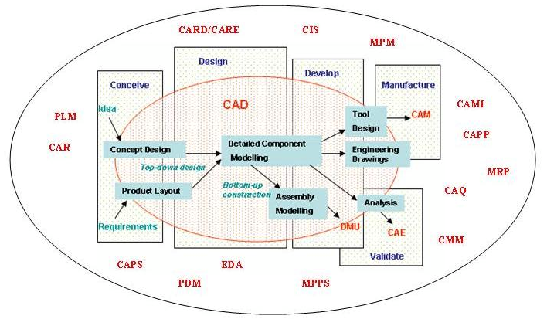

CAD/CAM informācijas sistēmu iespēju kopskats

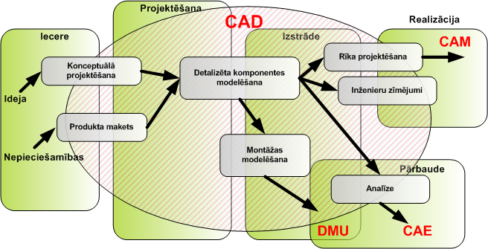

CAD sistēmas piemērs

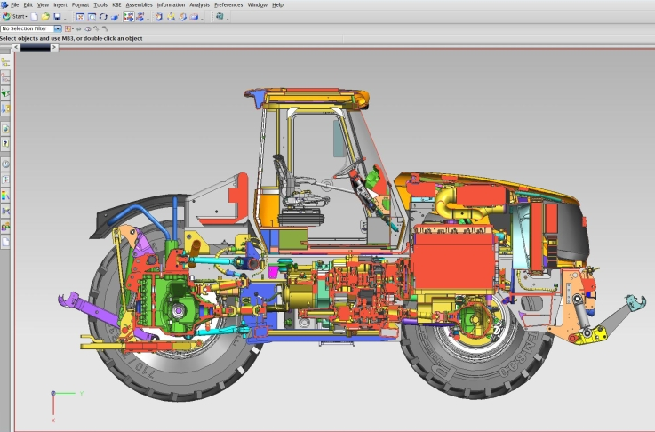

Computer Aided Manifacturing sistēmas

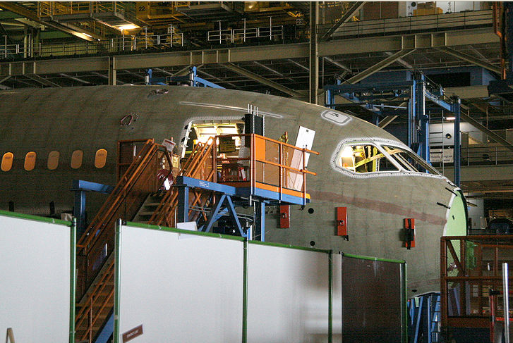

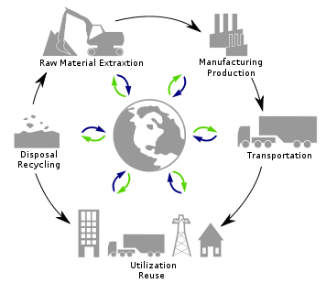

Ģeogrāfiskās Informācijas sistēmas sistēmas

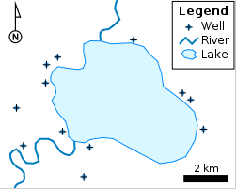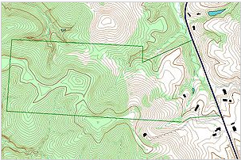

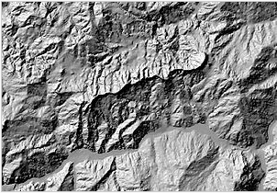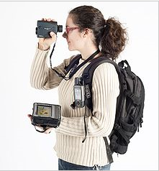

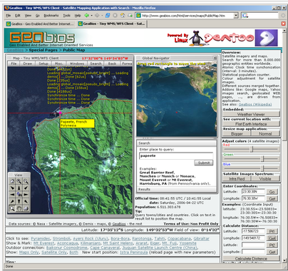

GIS companies with High Market Share
1. Autodesk – Products include Map 3D, Topobase, MapGuide and other products that interface with its flagship AutoCAD software package.
2. Bentley Systems – Products include Bentley Map, Bentley PowerMap and other products that interface with its flagship MicroStation software package.
3. ERDAS IMAGINE by ERDAS Inc; products include Leica Photogrammetry Suite, ERDAS ER Mapper, and ERDAS ECW JPEG2000 SDK (ECW (file format))are used throughout the entire mapping community (GIS, Remote Sensing, Photogrammetry, and image compression).
4. ESRI – Products include ArcView 3.x, ArcGIS, ArcSDE, ArcIMS, ArcWeb services and ArcGIS Server.
5. IDRISI – GIS product developed by Clark Labs, a part of Clark University. Economical but capable, it is used for both operations and education.
6. Intergraph – Products include GeoMedia, GeoMedia Professional, GeoMedia WebMap, and add-on products for industry sectors, as well as photogrammetry.
7. MapInfo by Pitney Bowes – Products include MapInfo Professional and MapXtreme. integrates GIS software, data and services.
8. RegioGraph by GfK GeoMarketing; GIS software for business planning and analyses; company also provides compatible maps and market data.
9.Smallworld – developed in Cambridge, England (Smallworld, Inc.) and purchased by General Electric and used primarily by public utilities.

Open source desktop GIS projects
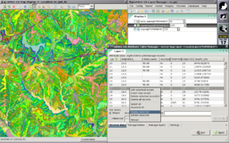
GRASS GIS – Originally developed by the U.S. Army Corps of Engineers, open source: a complete GIS
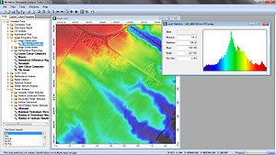
SAGA GIS – System for Automated Geoscientific Analyses- a hybrid GIS software. SAGA has a unique Application Programming Interface (API) and a fast growing set of geoscientifc methods, bundled in exchangeable Module Libraries.
Quantum GIS – QGIS is an Open Source GIS that runs on Linux, Unix, Mac OS X, and Windows.
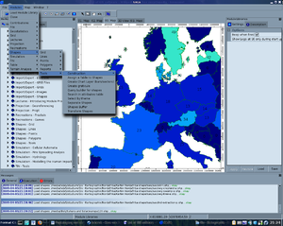
MapWindow GIS – Free, open source GIS desktop application and programming component.
ILWIS – ILWIS (Integrated Land and Water Information System) integrates image, vector and thematic data.
uDig
gvSIG – Open source GIS written in Java.
JUMP GIS / OpenJUMP – (Open) Java Unified Mapping Platform (the desktop GIS OpenJUMP, SkyJUMP, deeJUMP and Kosmo emerged from JUMP)

Spatial database

A spatial database is a database that is optimized to store and query data related to objects in space, including points, lines and polygons. While typical databases can understand various numeric and character types of data, additional functionality needs to be added for databases to process spatial data types. These are typically called geometry or feature.

The Open Geospatial Consortium created the Simple Features specification and sets standards for adding spatial functionality to database systems.

Geometry object model

The base Geometry class has subclasses for Point, Curve, Surface and GeometryCollection. Each geometric object is associated with a Spatial Reference System, which describes the coordinate space in which the geometric object is defined.

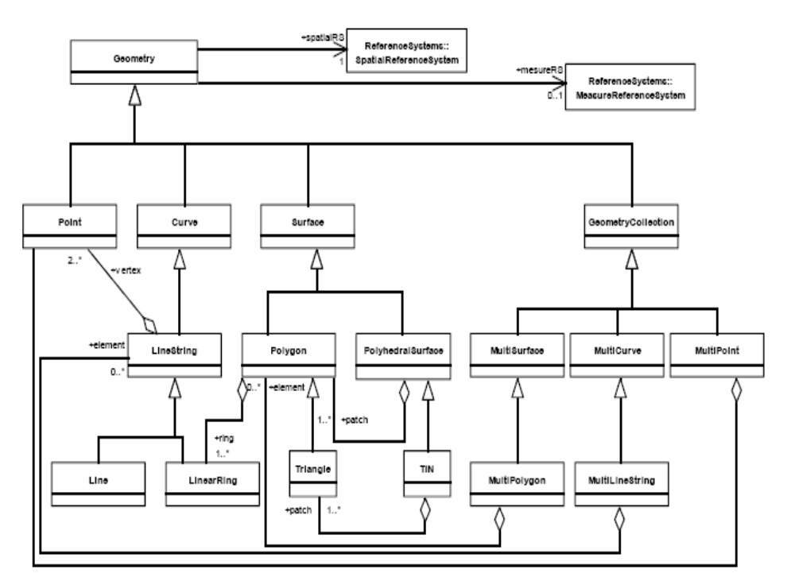

Spatial database systems
1. IBM DB2 Spatial Extender can be used to enable any edition of DB2, including the free DB2 Express-C, with support for spatial types
2. Oracle Spatial
3. Microsoft SQL Server has support for spatial types since version 2008
4. PostgreSQL DBMS (database management system) uses the spatial extension PostGIS to implement the standardized datatype geometry and corresponding functions.
5. MySQL DBMS implements the datatype geometry plus some spatial functions that haven't been implemented according to the OpenGIS specifications. Functions that test spatial relationships are limited to working with minimum bounding rectangles rather than the actual geometries. MySQL versions earlier than 5.0.16 only supported spatial data in MyISAM tables. As of MySQL 5.0.16, InnoDB, NDB, BDB, and ARCHIVE also support spatial features.
6. Boeing's Spatial Query Server (Official Site) spatially enables Sybase ASE.
7. Smallworld VMDS, the native GE Smallworld GIS database
8. Spatialite extends Sqlite with spatial datatypes, functions, and utilities.
9. Neo4j - Graph database that can build 1D and 2D indexes as Btree, Quadtree and Hilbert curve directly in the Graph (mathematics)
10. AllegroGraph - a Graph database provides a novel mechanism for efficient storage and retrieval of two-dimensional geospatial coordinates for Resource Description Framework data. It includes an extension syntax for SPARQL queries

Raster graphics

In computer graphics, a raster graphics image or bitmap is a data structure representing a generally rectangular grid of pixels, or points of color, viewable via a monitor, paper, or other display medium. Raster images are stored in image files with varying formats.

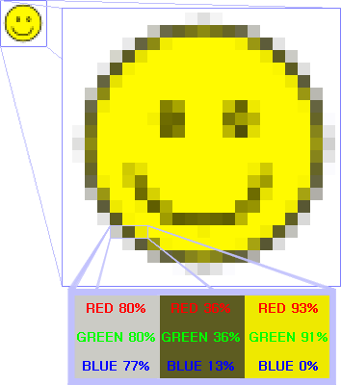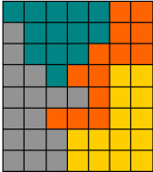

Raster graphics editors
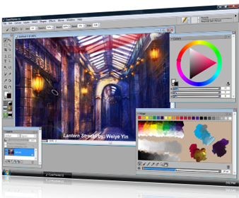
Proprietary software
Commercial | Freeware
 | ArtRage Starter Edition  Artweaver  Brush Strokes Image Editor  Effectbank  FastStone Image Viewer  Fotografix  IrfanView  Lunapic  Paint.NET  Picasa  Picnik  Pixia  Project Dogwaffle 1.2 Free Version  StylePix  SView5  TwistedBrush Open Studio  Xnview
  Ability Photopaint  ACD Canvas (formerly Deneba Canvas)  Adobe Fireworks  Adobe Photoshop  Adobe Photoshop Lightroom  Adobe Photoshop Elements  Autodesk SketchBook Pro  Aperture  ArtRage  CodedColor  Corel Painter  Corel Painter Essentials  Corel Paint Shop Pro Photo  Corel Photo-Paint  cosmigo Pro Motion | Digimage Arts Color It!  ERDAS IMAGINE  GraphicConverter  Helicon Filter Home/Pro  iPhoto  Konvertor  LView Pro  Manga Studio  Microsoft Office Picture Manager  Microsoft Paint  MST Viewer  Naked light  NeoPaint  OpenCanvas  Photobrush  Photogenics  Photoline  Photo Mechanic | PhotoPerfect  PicMaster  Pictor Paint  PixBuilder Photo Editor  Pixel image editor (formerly Pixel32)  Pixelmator  Portrait Professional  Project Dogwaffle  QFX  SAI  Serif Photoplus  TVPaint  TwistedBrush Pro Studio  Unified Color HDR PhotoStudio  Ulead PhotoImpact  Ultimate Paint  WinImages  Zoner Photo Studio
Vector graphics

Vector graphics is the use of geometrical primitives such as points, lines, curves, and shapes or polygon(s), which are all based on mathematical equations, to represent images in computer graphics.

A vector graphics editor is a computer program that allows users to compose and edit vector graphics images interactively on a computer (compare with MetaPost) and save them in one of many popular vector graphics formats, such as EPS, PDF, WMF, SVG, or VML.

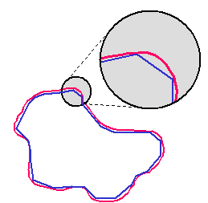

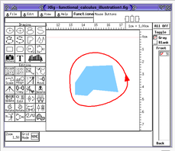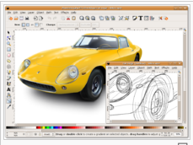

Vector graphics editors

 | Creator | First released | Latest version | List price (USD)
Raven | Aviary | 2009 | 1.00.00b | Free (closed source)
CorelDRAW Graphics Suite | Corel | 1989 | X5 (15) | $489, $189 upgrade (includes Photopaint)
Macromedia Freehand | Adobe Systems | 1988 | MX (11) | $399, $99 upgrade
Adobe Illustrator | Adobe Systems | 1987 | CS5 (15) | $599, $199 upgrade
Drawit [3] | Bohemian Coding |  | 3.7.3 (March 2009) | €29, Free Drawit Lite version
Chittram | Chittram | 2010 | 1.0 (July 2010) | Free (closed source)
Inkscape | Inkscape Team | 2003 | 0.48 (Aug 2010) | Free (open source)
Intaglio [4] | Purgatory Design | 2003 | 3.1.2 | $89
MagicTracer | Elgorithms | 2005 | 1.0 | $49
Mayura Draw [5] | Mayura Software |  | 4.3 (Sept. 2007) | €39
Microsoft Visio | Microsoft | 1992 | 12.0 | $560, $350 upgrade (Pro), $260, $130 upgrade (Standard)
Microsoft Expression Design | Microsoft | 2007 | 4.0 (7.0.20516.9) (June 2010) | (closed source)
OpenOffice.org Draw | The OpenOffice.org community | 2000 | 3.2.1 (June 2010) | Free (open source)
PhotoLine | Computerinsel GmbH | 1995 | 14.01 | €59
Serif DrawPlus | Serif Europe | 2010 | X4 | £79.99
sK1 | sK1 Team | 2009 | 0.9.0 (May 2009) | Free (open source)
Sodipodi | Sodipodi | 2000 | 0.34 (Feb 2004) | Free (open source)
Swift 3D | Electric Rain | 2000 | 6.0 (June 2009) | $249
Synfig | Synfig Team | 2005 | 0.61.09 | Free (open source)
Xara Xtreme | Xara | 1995 | 3.2 | $79
Xara Xtreme LX | Xara | 2006 | 0.7 | Free (open source)
ZCubes | ZCubes | 2006 | 2007 Dec | Free (closed source)

Triangulation graphic

